Virginia Breeze Bus Lines

Fourth Route Partner Toolkit

October 26, 2021

About the Fourth Route

Virginia Breeze Bus Lines is expanding its service to include a fourth route — the Highlands Rhythm! This route starts in Bristol, Virginia, and ends in Washington, D.C., with seven stops in between: Wytheville, Radford, Christiansburg, Salem, Harrisonburg, Dulles International Airport, and Falls Church. Starting November 15, the Highlands Rhythm will make one northbound trip and one southbound trip every day.

To help you help us get the word out about this new route and encourage Virginians to explore everything the Commonwealth has to offer, we’ve compiled information and sample social media posts that you can customize and distribute through various channels, including social media, websites, newsletters, emails, and any other channels you have available. Please tag our social media accounts (Facebook, Instagram, Twitter) in your posts!

Shareable Content To Promote the New Route

Press Event

Virginia Breeze Bus Lines is holding a press event in Bristol on Saturday, November 13, to announce a new route. You can tune in at 9:30 a.m. on their Facebook page to hear the announcement.

Social Media Event

On Monday, November 15, Virginia Breeze Bus Lines will host a virtual bus tour from 10 a.m. to 2 p.m. on Facebook and Instagram. The tour will begin with an introduction to the Highlands Rhythm route, then showcase historic landmarks, parks, museums, and tourist attractions at each stop along the route. You can tune in on Facebook or Instagram to follow the tour and share Virginia Breeze Bus Lines posts throughout the day.

Launch of the New Route

Virginia Breeze Bus Lines is expanding its service to include a new route — the Highlands Rhythm! This new route begins in Bristol, Virginia, and ends at Union Station in Washington, D.C. There are seven additional stops along the route: Wytheville, Radford, Christiansburg, Salem, Harrisonburg, Dulles International Airport, and Falls Church. Starting November 15, you can explore the sights and sounds of Virginia’s Highlands Region by hopping on this new route. For a full schedule and more information, visit virginiabreeze.org.

Web Content

Virginia Breeze Bus Lines is expanding its service to include a fourth route — the Highlands Rhythm! This route starts in Bristol, Virginia, and ends in Washington, D.C., with seven stops in between: Wytheville, Radford, Christiansburg, Salem, Harrisonburg, Dulles International Airport, and Falls Church. Starting November 15, the Highlands Rhythm will make one northbound trip and one southbound trip every day.

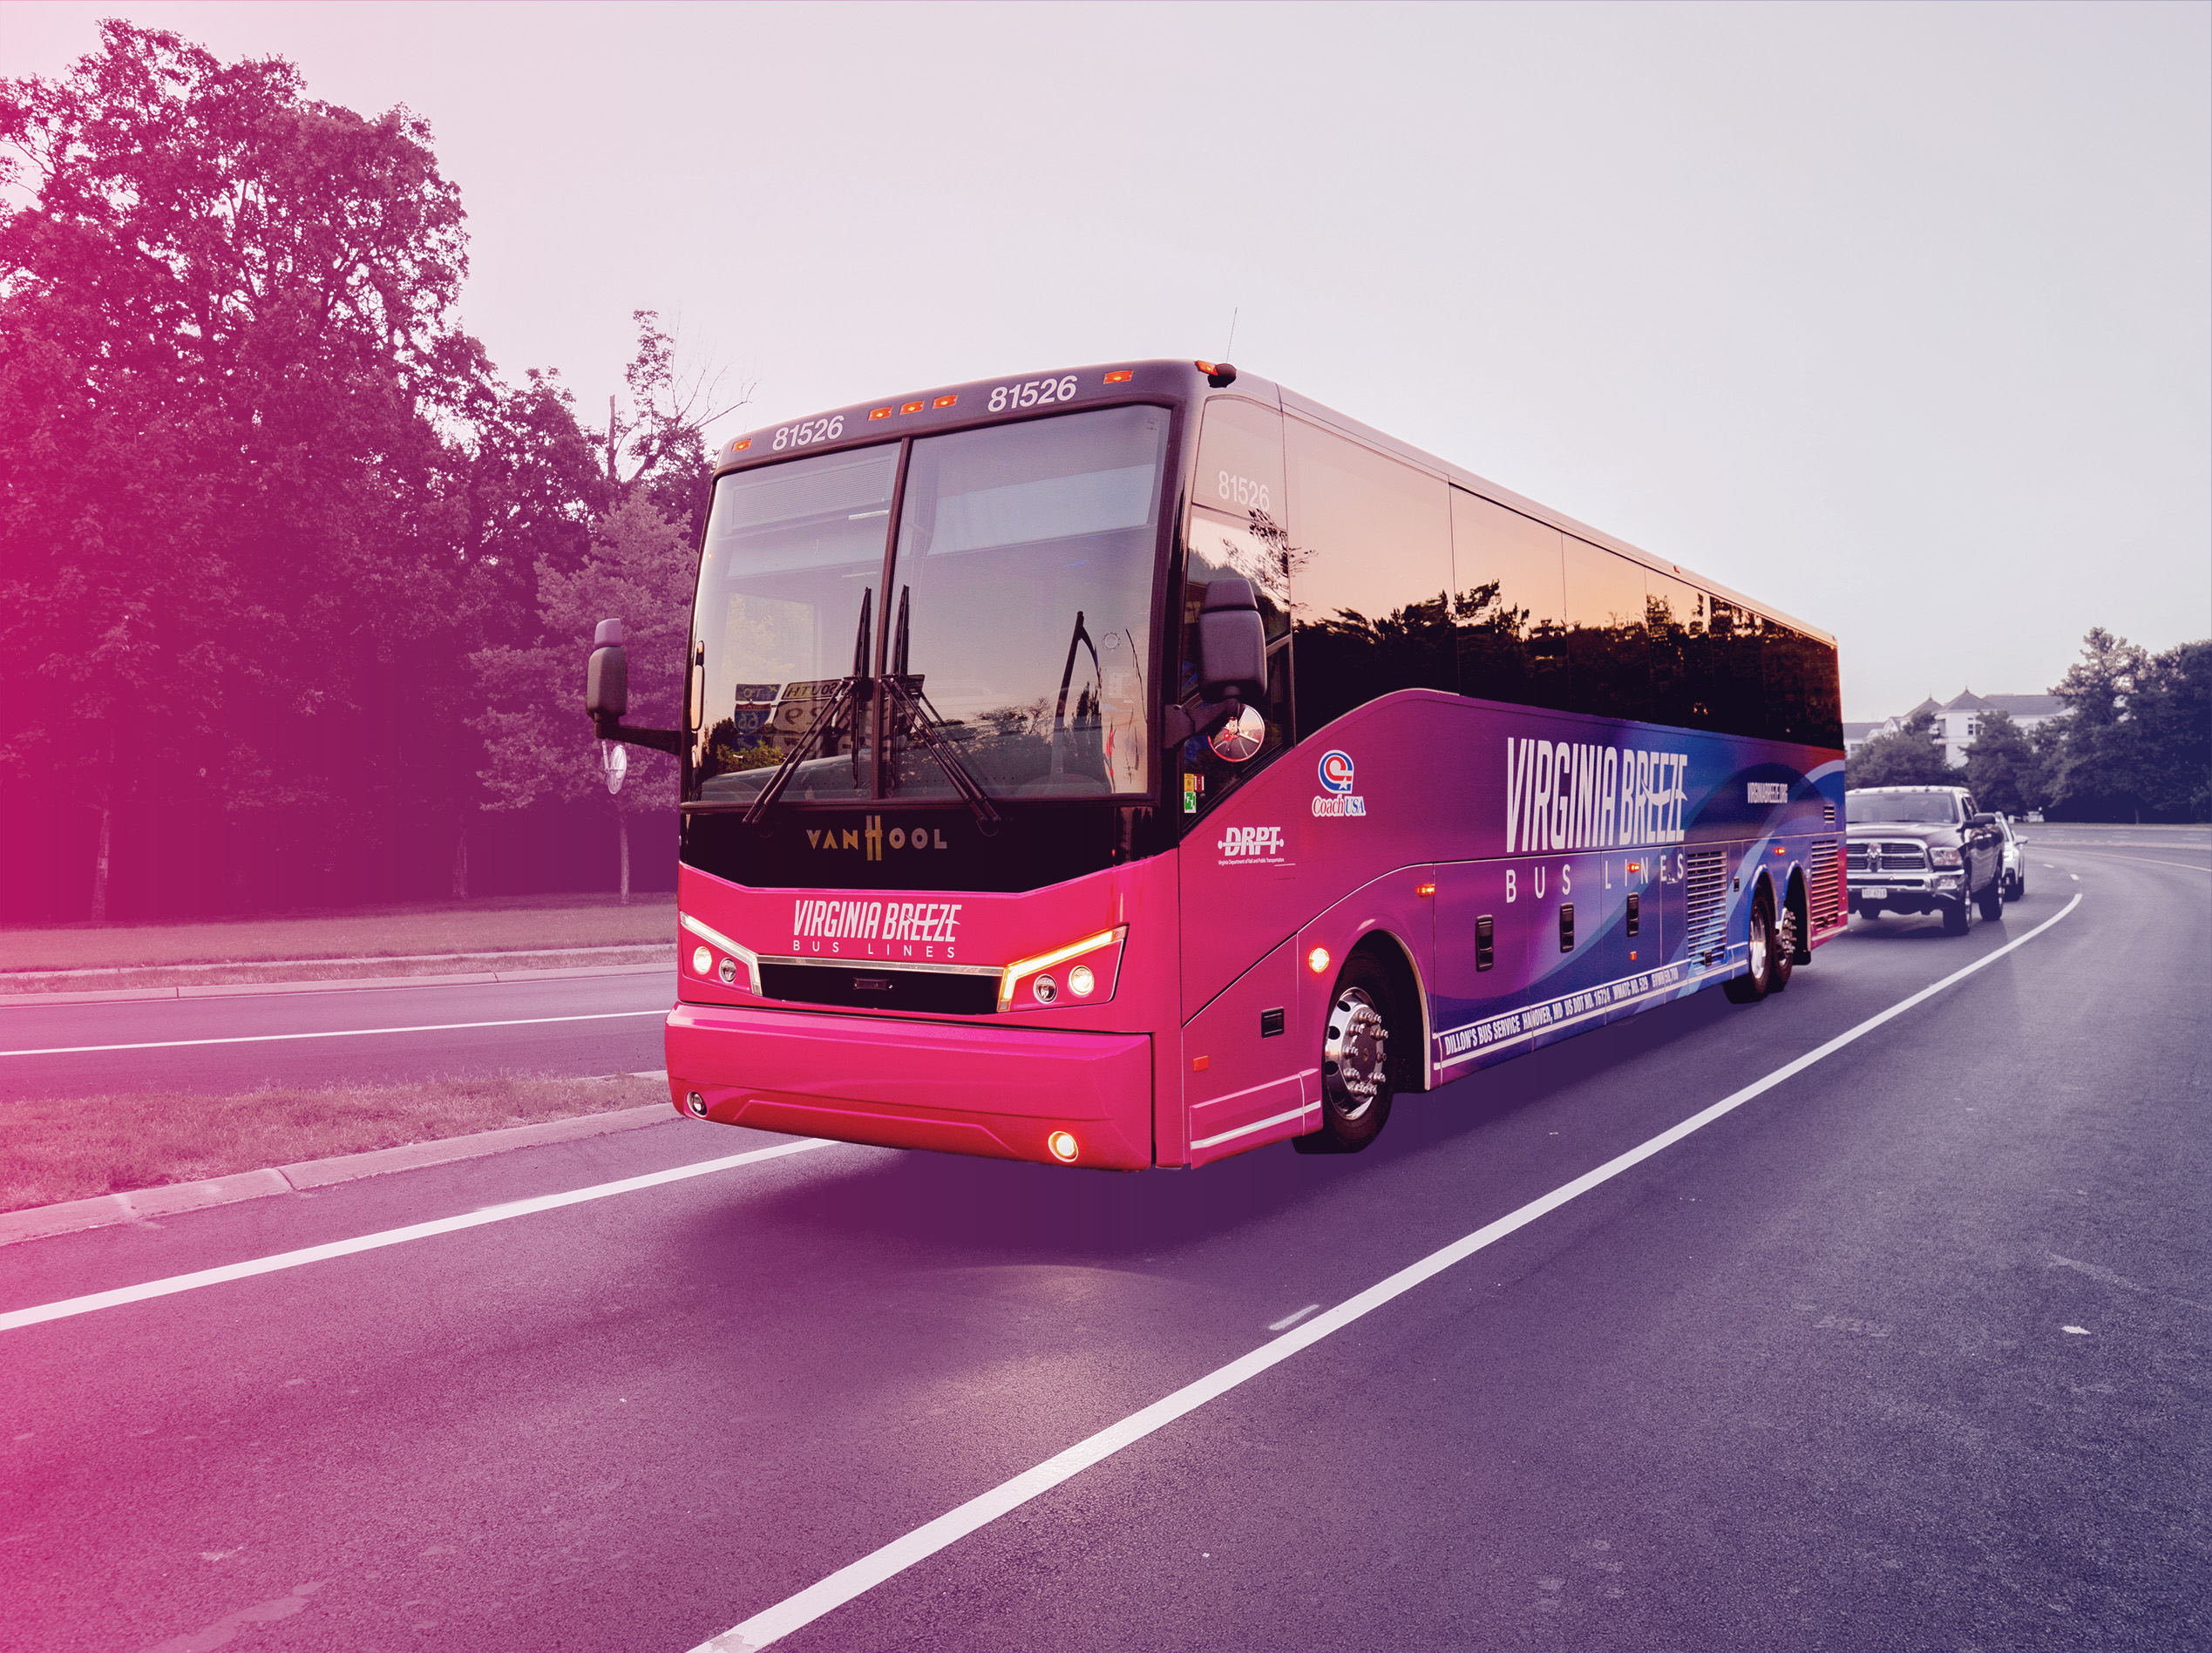

Email Content

Hi [name],

Virginia Breeze Bus Lines is an intercity bus service offering affordable, accessible, and convenient transportation that connects Virginia communities to one another and to Washington, D.C. This November, Virginia Breeze Bus Lines is expanding its service to include a new route — the Highlands Rhythm! This new route begins in Bristol, Virginia, and ends at Union Station in Washington, D.C. There are seven additional stops along the route: Wytheville, Radford, Christiansburg, Salem, Harrisonburg, Dulles International Airport, and Falls Church. Starting November 15, you can explore the sights and sounds of Virginia’s Highlands Region by hopping on this new route.

To celebrate the launch of the Highlands Rhythm, Virginia Breeze Bus Lines will host a virtual bus tour from 10 a.m. to 2 p.m. on Monday, November 15. The tour will begin with an introduction to the Highlands Rhythm route, then showcase historic landmarks, parks, museums, and tourist attractions at each stop along the route. You can tune in on Facebook or Instagram to follow the tour and share Virginia Breeze Bus Lines posts throughout the day.

For a full schedule and more information, visit virginiabreeze.org.

Thank you,

[name]

Social Media Content

You can use the social media posts below as is, or you can customize them to target specific audiences on your social media channels. Feel free to highlight special places to visit in your city or town, and encourage your audiences to get there by taking Virginia Breeze Bus Line’s new Highland Rhythms route!

Copy | Media Asset
Virginia Breeze Bus Lines is now offering daily service between Bristol and D.C., with a stop in [your town]!  Learn more about the Highlands Rhythm route at virginiabreeze.org. | 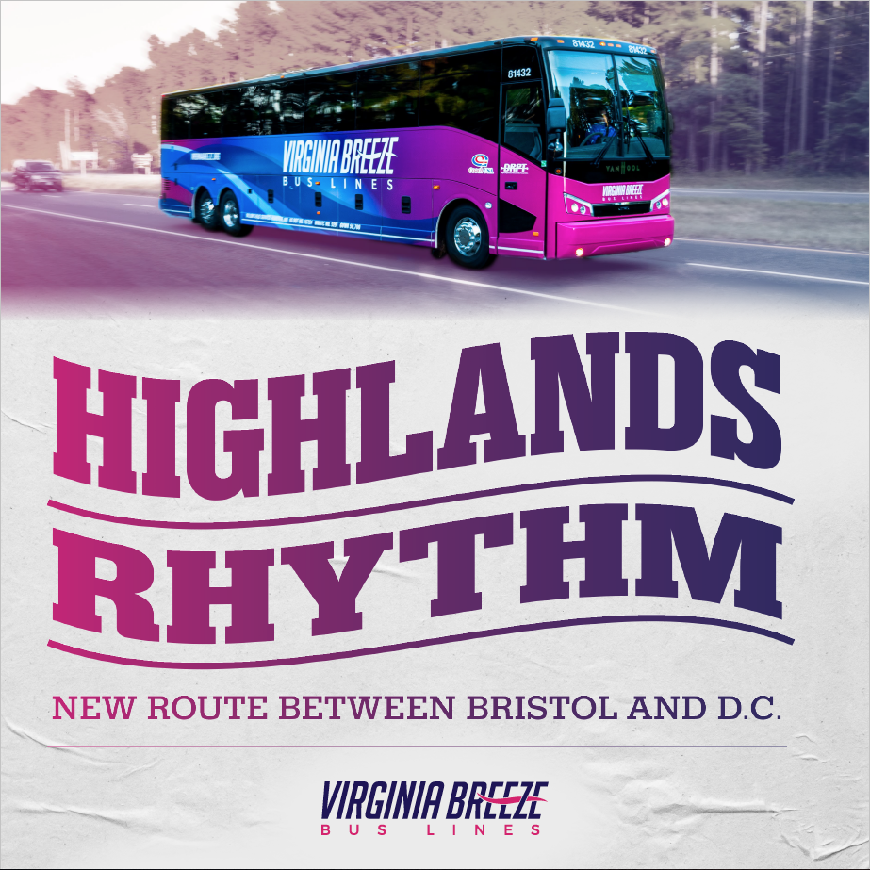
The Highlands Rhythm is music to our ears! Get excited for Virginia Breeze Bus Lines’ new route, now running between Bristol and D.C., with a stop in [your town].  Book your trip on the Highlands Rhythm at virginiabreeze.org. | 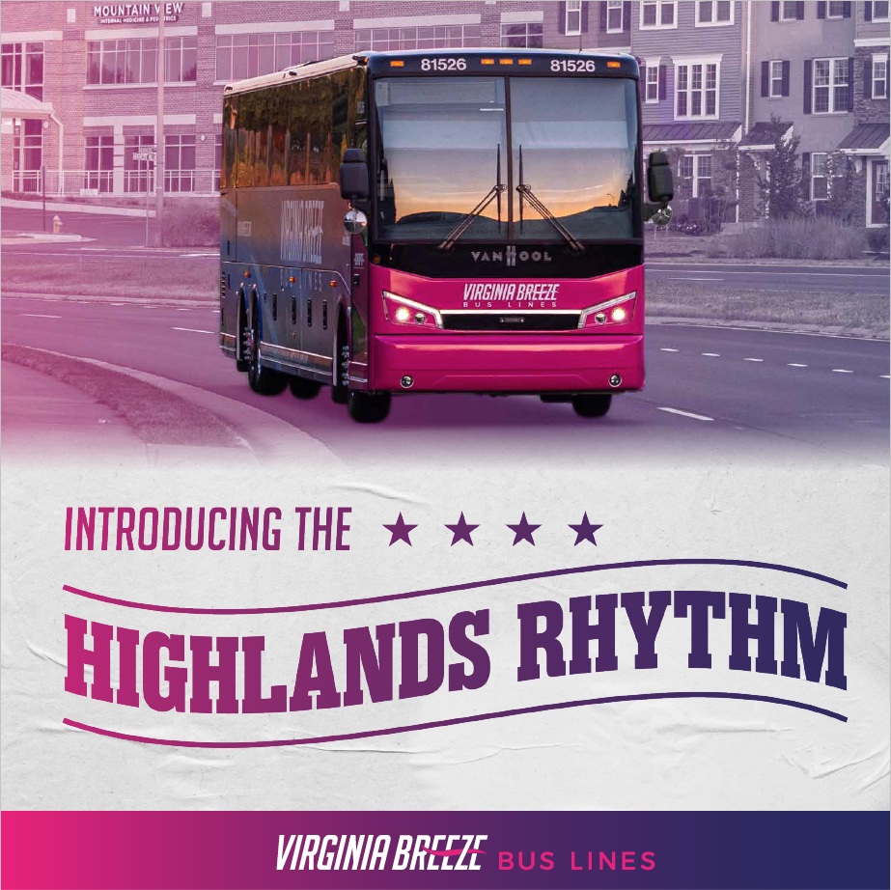
Hop on the Highlands Rhythm, your new connection between Bristol and D.C. — with 7 stops along the way, including [your town].  Buy tickets today at virginiabreeze.org. | 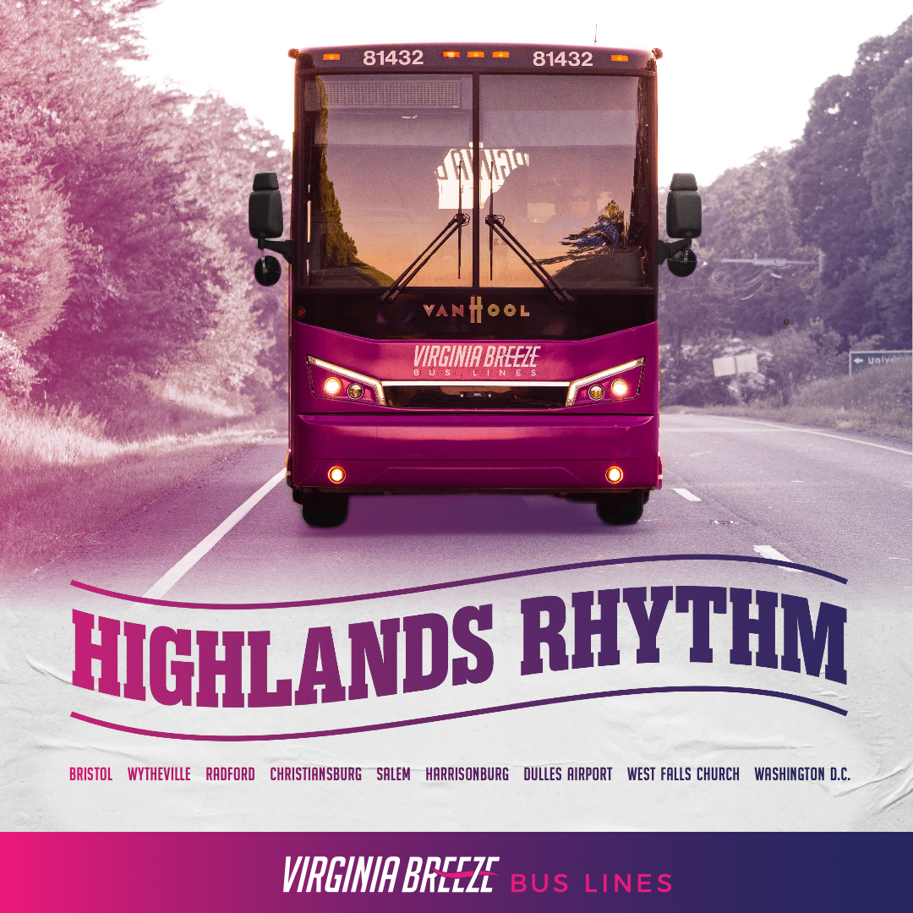
Virginia Breeze Bus Lines has a new route that runs from Bristol to D.C., with 7 stops in between — including [your town]!  Book your trip on the Highlands Rhythm at virginiabreeze.org. | 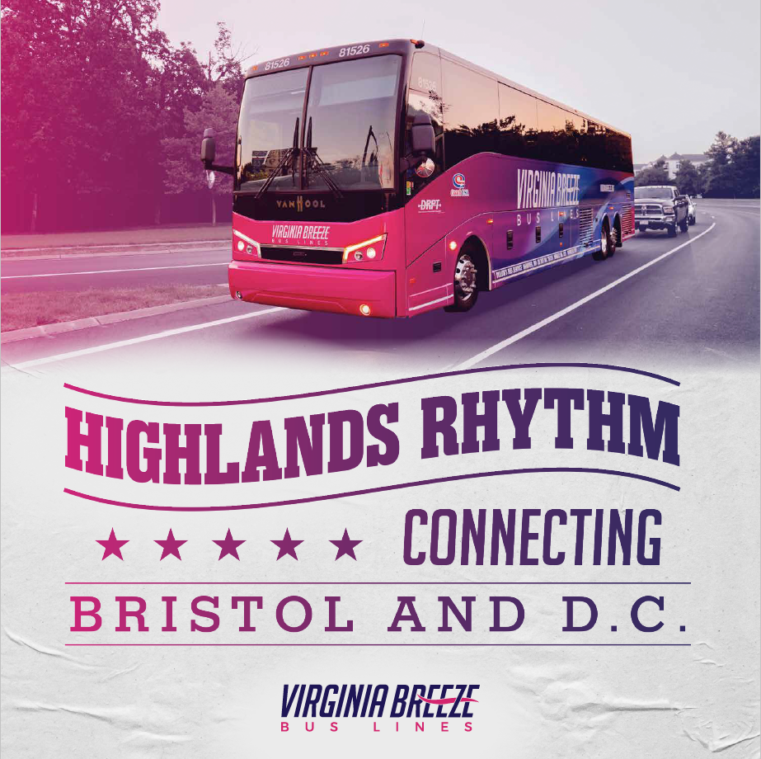
Ride the Highlands Rhythm! With affordable daily service, Virginia Breeze Bus Lines makes connections to destinations everywhere a breeze. Come visit us in [insert town] — a stop along the new route!  Book your trip at virginiabreeze.org. | 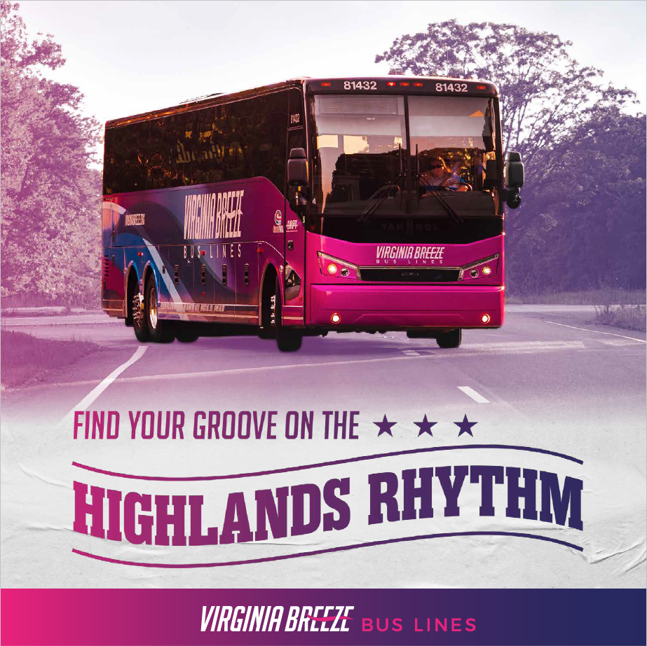

FAQ Responses

If you get any specific questions about the new Highlands Rhythm route, you can use the responses below.

Posts or messages inquiring about what Virginia Breeze Bus Lines is

Hi [name],
Virginia Breeze Bus Lines is an intercity bus service connecting towns and cities throughout the Commonwealth. With three routes — the Valley Flyer, Piedmont Express, and Capital Connector — and stops at Dulles International Airport and Union Station, you can catch a plane, a train, or another bus. Read more about the service at https://virginiabreeze.org/about-virginia-breeze/.

Posts or messages inquiring about the new route

Hi [name],

Thanks for your question! Virginia Breeze Bus Lines has four routes: the Valley Flyer, the Capital Connector, the Piedmont Express, and the Highlands Rhythm. Let us know if you have any more questions.

Hi [name],

Thanks for your question! The Highlands Rhythm stops in Bristol, Wytheville, Radford, Christiansburg, Salem, Harrisonburg, Dulles International Airport, Falls Church, and Washington, D.C. Let us know if you have any other questions.

Posts or messages inquiring about the bus schedules or stops

Hi [name],
For information about the bus schedules and the stops on each route, visit virginiabreeze.org.

Posts or messages inquiring about safety procedures

Hi [name],

Virginia Breeze Bus Lines has travel guidelines in place to keep you safe. Passengers and drivers are required to wear a mask at all times during their travel—from boarding to exiting. For information about other safety procedures, visit virginiabreeze.org.

